# Problem Statement

A company wishes to add user control for product categories for customers to choose a category and view the trend month-by-month and product-by-product. They will use Excel to analyze sales based on product categories and create a sales dashboard that breaks down sales by product category.

# Task

1. Create a Histogram for shipping days(aging)

# Output

1. Prepare a table of sales and profit month-wise in the working sheet

# Output

1. Prepare the sales table region-wise in the working sheet

# Output

1. Create a user control combo box for the product category

# Output



1. Create a column chart of the month-wise table and region-wise table

# Output

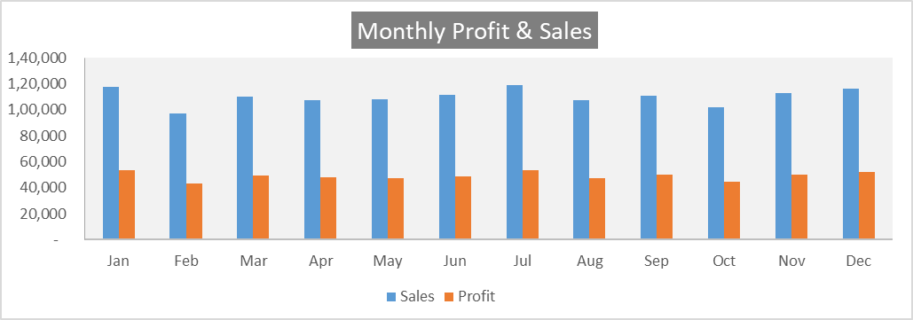

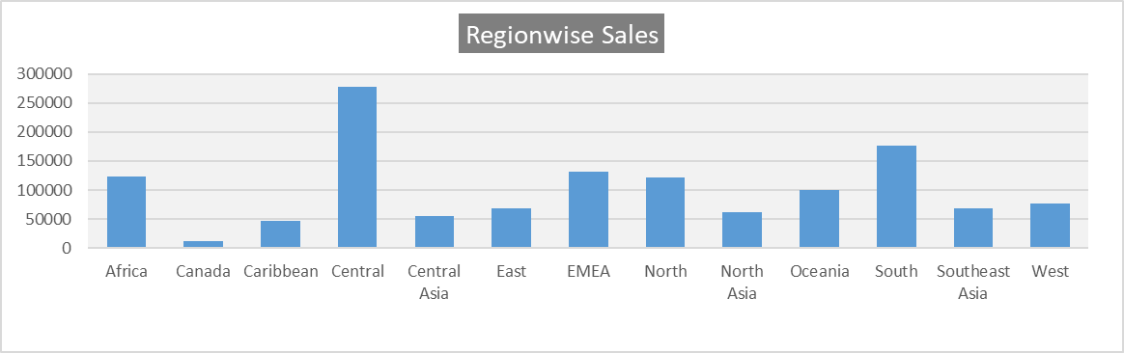

1. Link the table with a combo box

# Output

